Name: Nathanial Amador

Student ID: 1215332092  
Date: 4/24/22

**Instructions:** Congratulations, you made it to the end of the course! You should have at least six pages of your site completed by the time you submit this. Use the following to have a written discussion about your experience in the course and the final project.

**Before submitting this document and all of your project files, make sure you meet all of these requirements:**

* You have complete the “Final Submission and Discussion” worksheet.
* You have zipped up or compressed your final project folder (including all of your HTML, CSS, images, videos, etc.)
* You have one (1) home page and six (6) (but no more than eight (8)) content pages.
* **Each page** must contain appropriate text and images that provide information and value to the target audience.
* **Each page** must contain appropriate page titles.
* You must make use of the HTML5 tags (HEADER, NAV, MAIN, and FOOTER)
* You must include one (1) table utilizing data effectively (not per page).
* You must include one (1) video (you are not required to create the video, there are many sharable videos on the Web – chose one that is relevant to your project). The idea behind this is to use the <video> tag, so embedding all YouTube iFrames does not qualify (you can however just do 1 <video> tag and the rest YouTube embed iFrames – but make it easy for me to find the video using the <video> tag).
* You must include one (1) e-mail link.
* You must include one (1) external link (link to another page.
* **Each page** must contain appropriate description meta tags.
* You must include one (1) form (four (4) fields minimum. You do not need to setup the server side processing (since we really didn’t go over it in class). You can use **action=”#”**. Keep in mind, the form will not submit correctly when you hit the submit button. Additionally, you can use **action="http://webdevbasics.net/scripts/demo.php"** and it will accept any form fields you pass to it (keep in mind it won’t look right since it uses the pacific styling).
  + Form must reside on project site (linking to an external form is not allowed)
* You must include one (1) external style sheet (CSS) which contains a minimum of six (6) styles
* Do NOT screenshot the code because we can’t run the code. Save the file to yourasurite – Project – Submission 7 – Publish and Discuss Project.docx file and yourasurite – Project – Submission 7– Publish and Discuss Project.pdf file. Submit both files to Blackboard.
* Zip your FinalProject code folder and named it yourasurite-FinalProject.zip. Submit that zipped file to Blackboard too. Make sure you change “yourasurite” to yours asurite.

**Discussion Questions**

1. **Now that you are finished with your project, your original concept of your project might have changed a lot. Discuss in detail the differences between your initial project design and your final product. Why did you make these changes (if you had any)?**  
   The biggest change I made was deciding to not render my p5js sketches in browser. The reason for that was I wanted to showcase a lot of different p5js sketches at once and doing that while live rendering would be impossible on most machines even including my own.
2. **Describe in detail why you chose the design layout you did. Are you happy with the outcome? Did you run into any issues with your design while developing your site? What did you do to overcome those issues? Would you do anything differently the next time you designed a website?**

When it comes to colors, I tried to choose ones that I used a lot in my painting. This creates a bit of a pop when looking at my portfolio. I did not run into very many huge issues. The next time I design a site I will just start using flexbox out the gate instead of swapping to using it a third through my project.

1. **You likely encountered challenges while working on your final project. In detail, describe the challenges you encountered and what you did to overcome them.**

As I said above my biggest challenge was getting the p5js to look good in browser. Another issue I had was how to make a catalog of images since I didn’t want to stretch any of the images, but I wanted them in a somewhat fixed area. The solution ended up being using flexbox which makes a lot of sense now.

1. **Describe several concepts that you learned during this course that you found interesting and useful. Where there any concepts that you wish more time was spent on? Is there anything you would have like to incorporate into your final project that wasn’t covered during this course?**  
   I really enjoyed how the case studies showed almost a project flow for web design. I think that by far is one of the best take aways from this course since creating a website can be overwhelming and hard to start, so knowing how to start small and build from there really helped. I thought this course covered all the meat and potatoes when it comes to building a website and I don’t have anything else I would change.
2. **OPTIONAL (NOT REQUIRED FOR THE CLASS OR FACTORED INTO YOUR GRADE): If you took advantage of the “Getting Online” video in the Week 6 / Chapter 12 folder and setup a domain and hosting, what were your thoughts on the process? Did you run into any issues? What domain did you pick? Did you upload your files? You may have already answered this in the update #2, but some students wait until the end to complete this.**
3. **While trying to be as objective and unbiased as possible, please go through and critique your own site using the attached rubric. In the student critique column, indicate which score you should receive for each category (outstanding, average, or needs improvement) and write a short (1 or two sentence max) justification of that score.**

**Student Critique**

|  |  |  |  |  |
| --- | --- | --- | --- | --- |
|  | **Outstanding** | **Average** | **Needs Improvement** | **Student Critique** |
| **EXAMPLE** | You did everything! | You did a few things. | You did nothing… | Outstanding – I believe I did everything correctly because of x, y, and z. |
| **Discussion Questions: Answers** | Clearly and completely answered the questions. | Answers to questions could have been more complete or more clear. | Answers were missing. | Outstanding – I believe I did everything correctly because I answered each prong in the questions. Part of me wishes I could talk about challenges more but a majority of the issues I faced were fixed after a quick google search. |
| **Discussion Questions: Mechanics** | Organized, neat in appearance, easy to read and understand. | Some improvement is needed in the organization or appearance and/or the document is not easy to read or understand. | Answers were missing. | Outstanding – I believe I did everything correctly because I answered every part of each question and my sentences flow and are easy to read. |
| **Visual Appeal** | Use of color, contrast, text, graphics is appealing to target audience | Appealing to target audience in all but one area. | Not appealing to target audience in more than one area | Outstanding – I am really proud of how my website turned out. I know there are others with maybe a more modern look but I believe mine looks great since it complements my art so well which was what I was wanting. |
| **Navigation** | Easy to use, consistent | Inconsistent or difficult to use | Missing | Outstanding – My nav bar works great, I have titles on every page as well making it easy to follow an understand. |
| **Accessibility** | W3C Guidelines followed | Two or fewer instances where W3C guidelines are not followed | Three or more instances where W3C guidelines are not followed | Average – all of my images have alt text but I don’t think you can navigate it only using a keyboard unfortunately. |
| **Page Titles/ Logo Area** | Descriptive and include the site/company name | -- | Missing or does not include the site/company name | Outstanding – I believe I did everything right here since I have titles on every page, each nav bar is exactly what you see on the page, and the website name is in the top left at all times. |
| **Table** | Present and correct syntax | -- | Missing or incorrect syntax | Missing – I will be honest; I completely forget I needed this until now and it is too late to add one last second. My apologies. |
| **Graphics** | Present and correct syntax | -- | Missing or incorrect syntax | Outstanding – I have a great many images in my website so I should be covered here. |
| **Video** | Present and correct syntax | -- | Missing or incorrect syntax | Outstanding – I believe that I did everything right here since I have video tags under my programming page. |
| **E-mail Link** | Present and correct syntax | -- | Missing or incorrect syntax | Outstanding – I believe that I did everything right here since I have an email link in the footer. |
| **Outside Link** | Present and correct syntax | -- | Missing or incorrect syntax | Outstanding – I believe I did everything right here since I have links to openprocessing.org under programming and links to etsy under shop. |
| **Meta tag** | Correct syntax (description meta tags), excellent selection of keywords and meaningful description | Correct syntax (description meta tags), adequate selection of keywords and description | Missing or incorrect syntax | Outstanding – I believe I did everything right here because I have unique descriptions for every page on the site as well as great keywords for finding my site. |
| **Form Coding** | Contains 4 or more form fields, correct syntax, and meaningful form element names | Does not contain the required 4 form fields, incorrect syntax, or names of fields don’t make sense. | Missing | Outstanding – I believe I did everything right here because I created a form with 4 or more form fields under contact me. |
| **Form Processing** | Form uses # or the pacific.php script as the action. | -- | Form not configured correctly. | Outstanding – I believe I did everything right here since I included the php action shown above (not the pacific but it should still work) |
| **XHTML Validation** | Required number of pages pass | Less than the required number of pages pass | No pages pass | Outstanding – I believe I did this correctly because I have the correct number of pages |
| **CSS Validation** | External CSS file is present and passes validation | External CSS file is present but does not pass validation | External CSS file is not present or does not pass validation | Outstanding – I believe I did this correctly because it is present and should pass validation. |

**Web page browser view screenshot of Home Page**

**Web page browser view screenshot of Page #1**

**Web page browser view screenshot of Page #2**

**Web page browser view screenshot of Page #3**

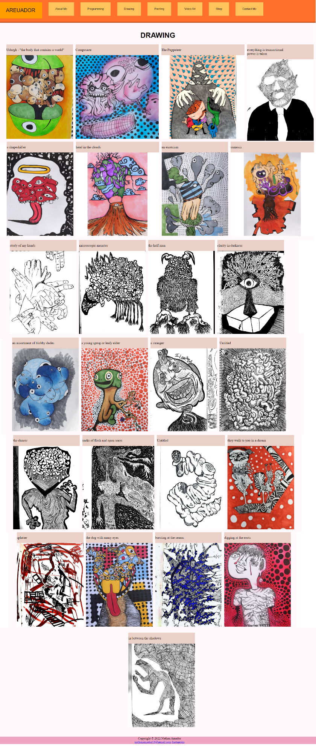

**Web page browser view screenshot of Page #4**

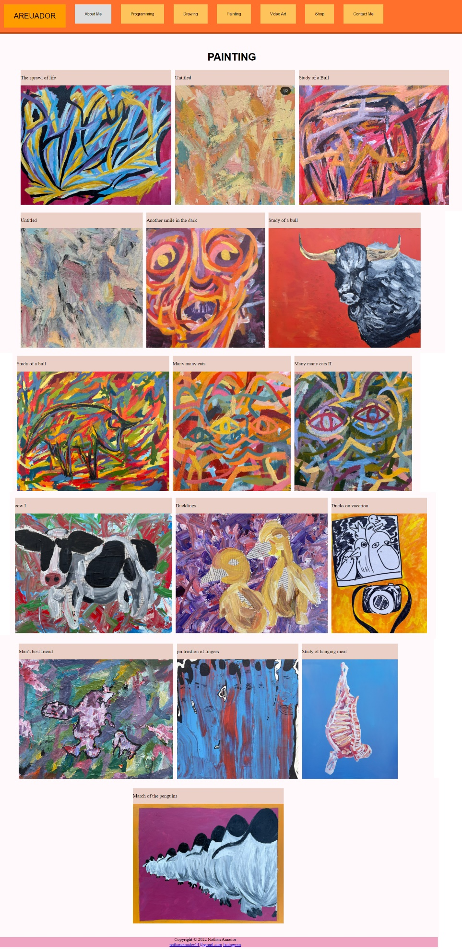

**Web page browser view screenshot of Page #5**

**Web page browser view screenshot of Page #6**

**Page 7:**

**Web page browser view screenshot of location you used a table**

**n/a**

**Web page browser view screenshot of where you used the <video> tag**

**Web page browser view screenshot of where you used an e-mail link**

**Web page browser view screenshot of where you used an external link**

**Web page browser view screenshot of your form**

**READY TO SUBMIT? MAKE SURE YOU ZIP/COMPRESS YOUR WHOLE PROJECT FOLDER AND ATTACH BOTH THIS DOCUMENT AND YOUR PROJECT FOLDER.**